ARTIFICial: Design Doc

Created by: Alec Sobeck, Dominick Schroer, Nick Tremblay and Spencer Gould

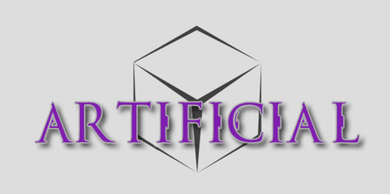

University of New Brunswick

MAAC3602

**Table of Contents**

**Design Philosophy**1

**Setting2**

Story2

World2

Tutorial3

**Player**4

Story4

Health & Shield4

Movement5

Combat5

Inventory6

**Dungeons6**

Dungeon Standards6

Dungeon Design7

Enemies9

Bosses15

**Outer Mechanics24**

Economy25

Loot25

Balancing25

Damage/Health Numerically26

Audio26

**Design Philosophies**

**Pillars**

1. Bio-Tech
2. World feels chaotic
3. Player’s world is manufactured
4. World revolves around the cube (Figuratively)

**Genre**

* Sci-fi
* Action/Adventure
* Loot based
* Single Player

**Pacing**

Loading screens at the end of all the depths and the beginning of the dungeon. This will help give some periods of respite between gameplay sequences. Along with creating **moments** during levels will help with the pacing, by making sequences with excitement that are fleeting.

**Moments**

Moments in our game are going to be mostly aesthetic. The bosses are going to the mechanical moments.

Examples:

* Bosses
* Special rooms
* Lore Rooms
* Harder depths
* Cube piece additions

**Why is our game fun?**

Our game is fun because it has a mysterious and intriguing world, challenging gameplay, and interesting combat. ***Artificial*** combines the fun of a dungeon crawler and the exploration of a constant and ever changing experience, with an intricate and unique flow.

The world flows together, each enemy fitting into its overall arch and story, allowing for a cohesive feel. The combat livens up the traditional dungeon crawler gameplay by increasing its pace and intensity and the shield allows for a level of mastery for player that push their own limits.

Overall, ***Artificial*** is an experience.New and interesting, and ready to be explored.

**Setting**

**Story**

Deep in the depths of space lies a small seemingly abandoned planet. You, a passenger aboard a large ship which you know only as The Sword, are told that your job is to seek out an alien artifact known as the “The Cube” which resides deep in the alien catacombs that lie under the planet and return it to the ship. You are then piloted it down to the surface, only to find out that its inhabited and very hostile. Your goal is to gear up and fight back, tracking down the cubes location by exploring the catacombs.

***Why is this interesting?***

The story is something that gives meaning to gameplay, but not forced on the player. I want to take a very FromSoftware approach to storytelling and let the player piece it together on their own, instead of flat out telling them what’s going on. The exciting part for people who are about the story will be searching for that hidden meaning and discovering it for themselves. It’s going to be mysterious and foreboding, a constant presence that isn’t revealed until the end. The interesting parts are discovering and unraveling the mystery.

**World**

The world consists of a singular planet, in which is a main alien biological and technological catacomb that the player must comb through. Each layer of the catacomb function as the domain of a Precursor(Boss), resulting in a slightly different feel.

The catacomb has various traps and layouts, changing constantly. The enemies the player encounters are similar across the catacomb but because of “The Cube’s” immense evolutionary power, have started to quickly adapt to the environments they live in. The catacombs are many layers thick and end in with a Precursor Tasked with guarding a piece of “The Cube”, and has sense evolved due to prolonged exposure to “The Cube’s” energy,

The player’s main hub is the Sword, a spaceship piloted by a highly advances, self-sufficient AI. This ship contains a rebuilding chamber, a pedestal that houses the pieces of “The Cube” and a massive door that leads to the AI and eventual final boss.

***Why is this interesting?***

It’s interesting because it’s a living a breathing world that the player can see resemblance to. As they progress in the game, the enemies and areas aren’t the same everywhere, the enemies taking form in their surroundings and getting progressively more fine-tuned to their environment. They also get to see the bosses, and their unique influences on the world around them as they progress, This contrasts with the ship to give a real sense of a living world that the player gets to experience.

**Tutorial**

The tutorial contains two distinct parts: an “onboard” part that deals with non-combat procedures and a “on world” part, that introduces combat.

**In part** 1: Introduces the player to the main game mechanics on the ship using the mysterious AI.

* **Room 1**:
  + You are shown to be put together by a massive machine before getting up and walking out of it and revealing to be in a small room with a singular door
  + The overheard AI tells him that there are items in the room in which explains his purpose. He must collect them and then open the door. (*The door won’t open if the player doesn’t complete the two objectives things.)*
  + After that, the player must complete two things:
    - There will be a book item on a table on the right side of the door. This allows the player to figure out that there will be book items and teaches them to pick it up. This book has his mission parameters and activates the Hud.
    - There are also two weapons on another longer table to the left side of the door. This allows the player to pick up both weapons for the first time and learn how to equip them. They can shoot them and when they pick up the weapons, there will be a text popup that tells the shoot controls.
  + Lastly is a door which can only be opened if the two objectives are completed. Once those are completed, the door with have a pop up when approached, telling the player the control to open it.
* **Main Hub Room**:

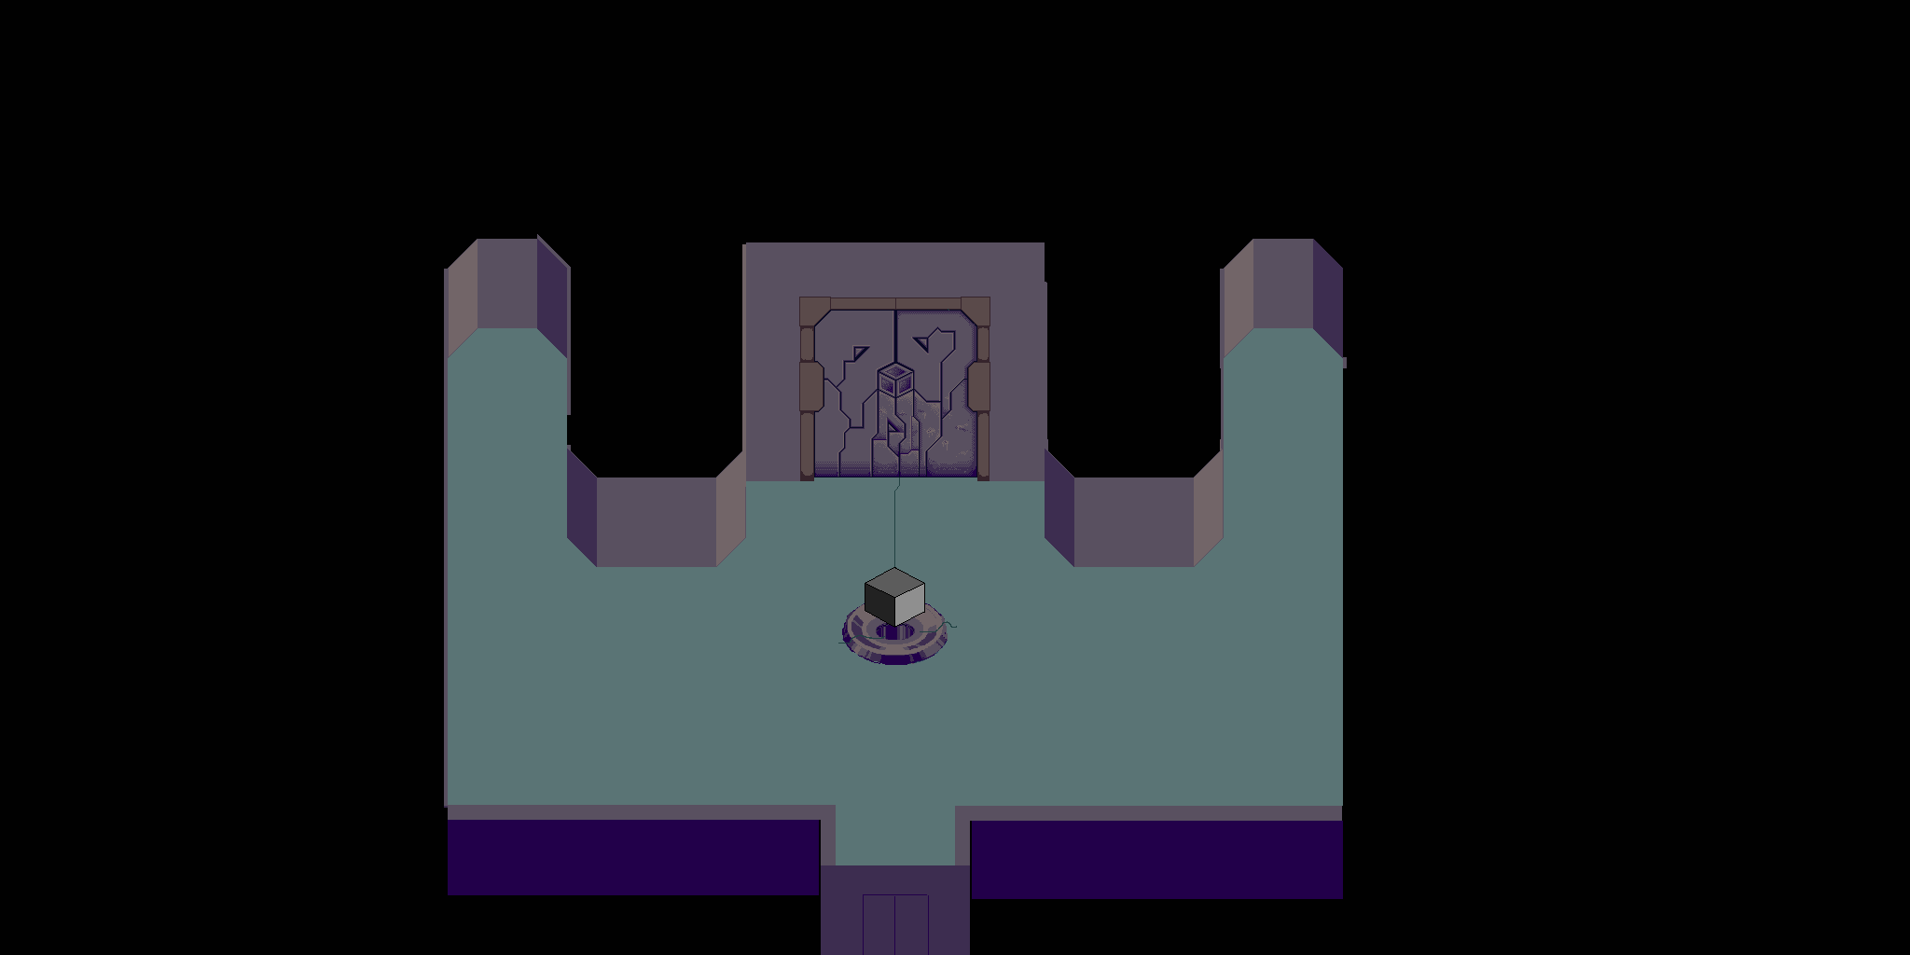



* In this main room, which is the main hub room for the rest of the game, you’ll find the pedestal for the cube pieces(C), the end game boss door(B), the respawn chamber(D) and the ground world teleporter(A).
* The player cannot teleport to the world until they have looked at each of the other three items.
* Once they have talked to them, the world teleporter will light up and the player can move to the second part of the dungeon, pressing the control to use the teleporter.

**In part 2**: Introduces the player to the combat system. This includes:

* How to attack
* Health and shields
* Enemies

The Dungeon has an empty "Start" room that served as a moment and an intro to the dungeon. It also allows for the player to fool around with their gear and prepare before starting the dungeon.

When you enter the first room in the Dungeon, there will be one enemy that can shoot at you. You must kill it at this point.

* Teaches combat with guns only, no shield. Also will show the reloading mechanic.
  + This first enemy will be a special one, very strong bullets and extremely accurate. To make sure the player gets hit. Cannot kill the player. Leaves them at one health.

Once the enemy is killed, the door will open and the player can proceed to the next room.

* Teaches the room clearing mechanic

The next room will have a new weapon and two health packs. The player must pick up all items to proceed.

* Teaches the weapon switching mechanic along with the health packs.

Once both those are picked up, the player can proceed to the next room. This is the last tutorial room and has a shield in it.

* Once the player picks it up and tests it, they can proceed into the first room of the dungeon.

***Why is this interesting?***

It’s transitioning between environments and its quick. It doesn’t bog down the player immediately with an insane amount of instructions but rather just teaches them as the player is presented with them. That’s why the combat isn’t taught until after the player has reached the dungeon. They don’t need combat in the ship, so why teach it there.

**Player**

**Story**

Name: J

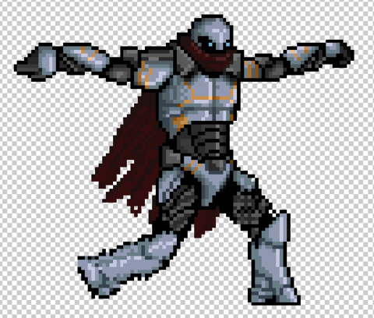

Bioengineered to be a perfect as possible, J is the tenth iteration in a program created to design the perfect organic being. His job, as explained broadly in the “Story” section, is to search for the pieces of “The Cube” and bring it to the native AI that resides on The Sword.

**Health**

Increases as you progress through the planets. Starts off low to incentivize learning the shield mechanic. Small health packs appear at the beginning of each dungeon depth, to help a little bit. But other than that, health packs are unreliable and using the shield is a far more sustainable strategy.

**Shield**

A toggleable ability that’s always present. Allows you to take damage without harm to your health pool.

* Mechanics
  + Active:
    - Can’t attack while it's active,
    - Drains its own health slowly.
    - Taking damage reduces its health for that damage
    - INSERT DIAGRAM
  + Recharges when not in use
  + When broken:
    - By taking damage that depletes its total health sets it on delay then starts to regenerating
    - Taking massive damage delays it longer
    - Taking immense damage sets it on a huge delay
  + Can’t take health damage at all when blocking with a shield, no matter how much damage you absorb. Even if the shield absorbs more than it has health.
* Visuals
  + When active, covers player with a blue circle
  + When broken, it pops off with an animation
  + More broken it is, the larger the popping off animation.
  + INSERT DIAGRAM

**Movement**

* Walks around, can't jump.
* Standard movement.
* Feels smooth, stops slightly after the input ceases depending on speed of travel, a little delay as possible to his movement. He’s dodging gunfire.
* He moves fast regularly, increasing his speed the more you move to left stick to the edge of the controller.
  + Technical:
    - Dual Stick movement. One stick moves him, the other allows him to pick a direction to shoot.
    - On PC, just use WASD for movement and the mouse for shooting direction.

**Combat**

* He can shoot independently of moving, thanks to the dual stick.
* He has knockback recoil to shooting regular weapons. Bigger weapons have larger knock back.
* He has infinite ammo, but must reload. This takes away the problem that Borderlands has in which you must put yourself in danger to get ammo. When he reloads, a bar appears on the player and slowly fills as the player reloads.
* INSERT DIAGRAM

**Inventory**

* He can hold two weapons at once and can switch between them. He can also carry a shield.

**Dungeons**

**Level Standards**

* Each depth consists of a finite number of floors, determined before the dungeon is entered.
* The floor numbering corresponds to the depth in the dungeon, so floor #1 is at depth 1, floor #2 is at depth 2, and so on. As the depth increases, the difficulty will scale up.
* Each floor has a starting/entrance room, and an exit room. The starting room contains a teleporter back to the hub ship. The exit rooms bring the player deeper into the dungeon.
* The final floor of a dungeon has a boss. This boss guards/drops good loot, a map to the next zone, and a piece of “The Cube”.
* After a boss is defeated, the player can progress to the next stage of the dungeon/next set of depths.

**Loading Screens**

* Start at the beginning, and at the beginning of every subsequent depth change.

**Enemy Standards**

* **Shadows:** Under each enemy is a shadow that communicates difficulty
* **Weapons:** They don’t reload. Most enemies won't just spam damage out though, they will have basic pausing when they fire. Ex. Fire three bullets then a small pause. (Bursts)
* **Drops:** Drop weapons based on their status as an enemy. (Size and strength) Weak weapons
* **Movement:** Don’t pause to attack unless specified. Turn speed is same as the main characters unless specified.
* **Distance:** Runs on a basic three circle system. Long, medium, and short.



Long: These enemies want to stay at a long range from the player, and don't like close range encounters.

Medium: These enemies want to stay a small distance away from the player.

Short: These enemies want to get all up in the player’s business and f*ck them up.

**Dungeon: Vardus**

**Level Design**

Emphasis on larger rooms with more space to move. Fits the more barren theme of the world and give the player some extra breathing room to learn the game mechanics.

**Rooms**

Most rooms are rectangular with some exceptions.

* **Small Rooms:** Connections to the bigger rooms, creating a more organic feel. I want at least one small room in between large rooms. Not too many smalls rooms in a row.  Maximum two.
* **Medium rooms:** Can be used interchangeably with small rooms for the first dungeon.
* **Large rooms:** Most of the dungeons makeup.
* **Oblong Rooms:** Rooms that are not square or rectangular.

**Enemy Placement**

* Small enemies will be plentiful in the large rooms, but spread out. They are consistently in all types of rooms.
* Medium enemies will be placed in small groups, only in the large rooms and medium rooms towards the end of the layer.
* Heavy enemies are only aloud to spawn alone (Can't spawn as a pair or group) and go in the medium rooms. One must be placed in the exit room and have some extra enemies in later depths.

**Difficulty Escalation**

* This dungeon has 3 depths before a boss. The depths will slowly get harder as the enemies increase in strength, forcing the player to player better.
* The bosses will be difficult and hard to beat but once the mechanics are learned, shouldn’t be to hard to beat repeatedly as you are required.
* Once a boss is beaten, the player gets access to the next depth to progress through, which has a slight fall in difficulty at the beginning to make up for the boss difficulty.
* It will then ramp back up and be hard again by the time you get to the net boss.

**Traps**

* Stall trap:
  + Size: One floor tile
  + Effect: Catches the player and stops them from moving for 5sec
  + Damage: None
  + Spawns: Any room
* Spike floor:
  + Size:4 floor tile
  + Effect: Does decent damage as the player passes over.
  + Damage: Medium, can be avoided by shielding
  + Spawns: Medium and big rooms
* Indiana Jones Rockfall(Optional):
  + Size:4 floor tile
  + Effect: Rolls from a wall across to the opposing wall and comes back. Slow
  + Damage: high, can be avoided by shielding
  + Spawns: Big rooms
* Pit floor:
  + Size: Room specific
  + Effect: Instant kills the player if they fall in it. Maybe spawns them at the beginning of the depth.
  + Damage: ^^^^^^^^^^^^^^^^
  + Spawns: Room specific.

**Enemies**

**Grunt**

**Story**

Weak enemies. They have not fully take form and serve only to strengthen themselves and grow.

**Type:** Weak

**Distance:** Medium

**Health:** 40

**Damage:** 10 per bullet (3 bullets per attack sequence)

**Aesthetic:** Work in progress. Going along with the theme of biotech, most likely cyborgs slimes.

**How the enemy will attack**

They have a small pistol that fires at a semi-automatic rate. The projectiles they fire will be on the faster side but do weak damage to offset their quick speed. They don’t have a melee.

**Audio:** Small laser sound.

**How they will move**

They move slow, waddling around. By waddling I mean that they sway from side to side a bit when they walk. They back up from the player when he gets closer to them. Move slower than the player.

**Audio:** small, light footstep sounds.

**Range of attacks**

Their weapons don’t have damage fall off, they can hit the player for full damage from any range. When the bullets hit the walls, they go away. See distance for more info.

**Strengths**

Numbers are their strength.

**Weaknesses**

Don't can burst down the hero's health. Don't deal enough damage to hurts the player substantially. They are just weak. Very basic.

**Death**

When they die, by regular bullets, they fall over in the opposite direction that they were shot from. Have a very small chance to drop a weapon.

**Audio:** an obnoxious death sound, either loud and drawn out or funny, like a funny “AHHHHHHHhhhh…..”

**Why is this enemy fun to fight?**

These would be more of the comedy enemies. Because they’re easy to kill, the fun won't be the challenge of them, but more of how they die or act. They act in a horde of funny and awkward enemies.

**Dog**

**Story**

Weak enemies. Run in packs and attack with captains as their handlers on occasion.

**Type:** Weak

**Distance:** Medium

**Health:** 20

**Damage:** 15 per bite

**Aesthetic:** Stone dogs.



**How the enemy will attack**

Mainly a melee attack where they rear back and jump at the player. They also hunt in packs.

**Audio:** Chomp sound

**How they will move**

Running at the player. They run fast then the player.

**Audio:** small, light footstep sounds.

**Range of attacks**

They bite. They have no range.

**Strengths**

Numbers are their strength.

**Weaknesses**

Don't can burst down the hero's health. Don't deal enough damage to hurts the player substantially.

**Death**

When they die, by regular bullets, they fall over to the side.

**Audio:** an obnoxious dog dying sound

**Why is this enemy fun to fight?**

These are the annoying enemies that attack fast and often, making killing them satisfying because there really annoying to fight.

**Captain**

**Story**

Smart and fluid warriors, the Cube created these to help make the army’s more varied and adaptable. There distinct fighting styles only illustrate that further.

**Type:** Medium strength

**Distance:** Long/Short

**Health**: 150

**Damage**: 20 per bullet (5 bullets per attack sequence)

**Aesthetic**

Like the Captains or Vandals from Destiny. Tall and lanky with a cape. Decently balanced hitbox to their size.

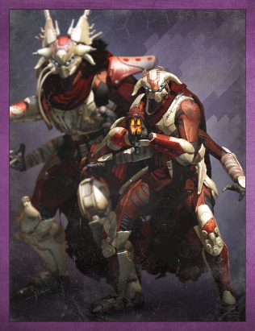

**How the enemy will attack**

Fire a long burst of average speed projectiles that if all connect on the player will deal a moderate amount of damage. They get flustered if the player is close to them and won't attack as often or focus more on running away.

**Audio:** a strong bullet sound that repeats over the burst.

**How they will move**

Speed is at the same as the player. Hang back and pop shots from a distance, either putting some other enemies in front to take the brunt of the damage and/or jumping behind cover when taking too much damage.

**Audio:** A light stepping noise as they walk. A grunt when the jump behind cover.

**Range of attacks**

They can be primarily longer range.

**Strengths**

Long range and decent damage combined with a pack of dogs make for a deadly combo.

**Weaknesses**

Can be take out very easily by getting close to them and dealing burst damage.

**Death**

When they die, by regular bullets, they fall over in the opposite direction that they were shot from. They have a small chance to drop a weapon.

**Audio:** Deeper more gurgling death sound.

**Why is this enemy fun to fight?**

Due to the long range and relatively equal damage to the player, this is a fight that feels like you going toe to toe with a character as strong as you. This requires a more cautious play style to circumvent their larger damage profile.

**Brute/Golem**

**Story**

These enemies are large and hulking tanks of the battlefield, created to specifically protect and reinforce the front lines. They have evolves faster given their increased organic to robotics ratio and allowed the cube to fashion them new strengths.

**Type:** High strength

**Distance:** Short with a long-ranged ability

**Health:** 500

**Damage:** See “How the enemy will attack”

**Aesthetic:** Large with massive arms and a stone body.

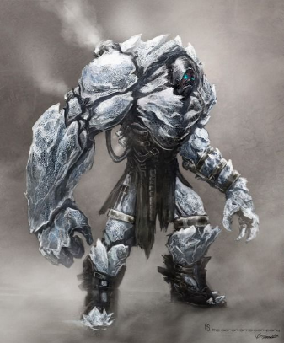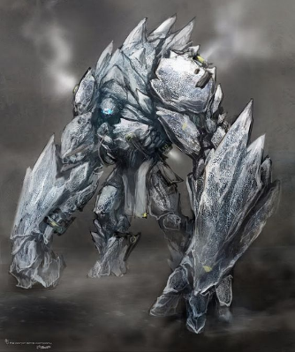

(this is ice but you get the idea)

(*Insert actual art here*)

**How the enemy will attack**

* The swing their large arms for a heavy melee that hits the player. **Deals 100 damage**
* They can also slam the ground with knocks the player back, dealing damage (*Optional: More damage if they hit a wall*). **Deals 50 damage**
* There last attack is a boulder throw. A medium speed projectile that does A LOT of damage. **Deals 150 damage**

**Audio:** Big heavy sounds with a lot of oomph. Earthy tones.

**How they will move**

Slow but with a lot of weight. They walk on two legs but are hunched over. (Like above). Pause to attack, and wind up a lot for the slam. Turn speed is slow.

**Audio:** Heavy sounds.

**Range of attacks**

Short range except if they are at long range, they can throw a boulder.

**Strengths**

Heavy damage output and a lot of health.

**Weaknesses**

Very slow. Can’t turn fast and have long windup to their attacks.

**Abilities**

Their boulder throws and slams are there two more unique abilities. Explained above.

**Death**

When they die, by regular bullets, they fall forward (in the direction they were facing) and smash into the ground, hard. Drop a decent item and maybe a good item.

**Audio:** Low deep moan.

**Why is this enemy fun to fight?**

They are extremely dangerous and hard to kill, requiring a good foresight to avoid their attacks and a strategy as they are rarely fully alone. They must be kept at a distance, as they do a lot of close range damage, but their boulder throws can easily kill you. They are satisfying to fight because they are challenging.

**Bosses**

**Story**

The bosses are part of an old group of highly intelligent and powerful beings. They were all extremely unique, being each part of dying races after a massive black hole engulfed much of their galaxy in its dying breath. They lived together in harmony, advancing, and becoming and extremely proficient and power group of diverse aliens.

But after a particularly risky experiment, a lone scientist created “The Cube”, a powerful hyper-intelligent AI that could morph and change matter at will. This “Cube” became the center piece of the groups scientific community, bolstering great change over the alien races they lived with. But some races wanted it for themselves.

A great civil war broke out over possession of the “Cube”, wiping out most of the planets inhabitants, leaving all but 4. They all came to an agreement; the cube was much too powerful to be left for one single being. So, they broke it into 4 pieces, each taking it deep within the planet and guarding it with their lives.

**Boss Standards:**

* When they get to a certain health point, they alter the fight in a way like Lady Maria (Bloodborne). they don't change to much in mechanics but they require better play.
* Boss specific weapon that is very good. Very low drop rate.
* They have three main mechanics: Movement, Attacks, Weak Point.
* They also have a depth mechanics, something that is active in the levels leading up to the bosses. Music also changes.
* Once a boss is defeated three times, you unlock a shortcut. You can teleport to the cube piece room behind the boss room from that point on instead of going through the full depths leading up to it. You can still choose to go through and fight the boss each time.

**Why don’t the bosses die?** Its inherent to the cubes power. Extended exposure with the Cube make the cells in the organism’s body extremely durable to the point where even killing the being, the cells will reconstruct. That’s why you teleport past there room and not to the killed boss room. They’re not dead.

**Azar, The Unbreakable**

**Story**

Due to his long exposure to the Cube, his massive stature and his alien rocklike body morphed and evolved him onto a perfect and powerful golem. He became the first line of defense in the catacombs they had created for the cubes protection.

**Health:** 2000

**Phase switch:** 50% health left.

**Damage:** See “Attack”

**Aesthetic**:

* Giant stone statue (Tech mixed with Stone)
* Has a massive core in his chest
* Pieces of stone float around him(*Optional*)

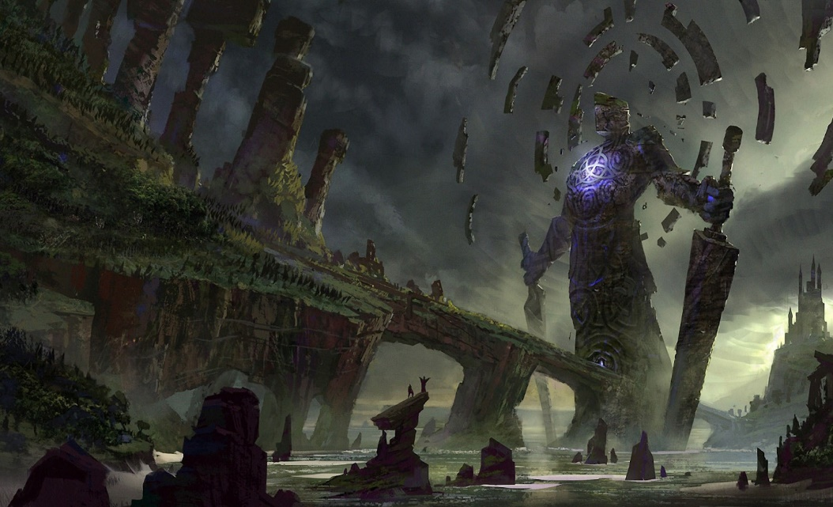

*(Art from Google)*

**Depth Mechanic:**

* Every now and then, the screen will shake and the player will move slower. Like an earthquake

**Boss Room:**

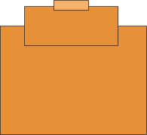

**Phase 1**

**Movement:**

* Disassembles and floats in a cloud of statue parts to the four sides of the room.
* Or Jumps?
* His attacks are slow

**Mechanic:**

* He shakes the screen as he walks

**Attacks:**

* **Attack 1**: Basic Attack
  + **Range:** Short
  + **Damage:** 50(per hit) 3 hit combo
  + **Effect:** Three hit combo and the final hit will knock the player around
* **Attack 2**: Ground Slam
  + **Range:** Short
  + **Damage:** 75(per hit)
  + **Effect:** Heavy knockback on attack
* **Attack 3**: Rock Wave
  + **Range:** Medium
  + **Damage:** 75(per hit)
  + **Effect:** Sends out a rock wave in a cone out in front of him
* **Attack 4**: Rock Throw
  + **Range:** Long
  + **Damage:** 150(per hit)
  + **Effect:** throws a massive rock at the player

**Weak Point:**

* Center of his chest.

**Phase 2**

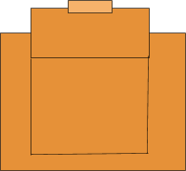

^Updated boss room after he creates the walls.

* He pulls the walls in, Making the room smaller
* This makes it harder to avoid his attacks and creates a larger sense of urgency.

**Weapon:** Azar’s Will

**Type**: Assault rifle

**Magazine size:** Large

**Damage:** Moderate

**Effect:** Slows enemies by making tiny earthquakes around the player.

**Dym, The Living Shadow**

**Story**

Dym is a highly intelligent but mysterious being, being able to create small living organisms that he can will into his command while also having an immense temper. The cube bolstered this ability, granting him the ability to create massive clouds of the organisms to help defend himself and enhanced his temper, making him extremely volatile and randomly aggressive.

**Health:** 5000

**Phase switch:** 50% health left.

**Damage:** See “Attack”

**Aesthetic**:

* Creepy shadow creature
* Has a massive cloud/flies that float around him, blocking damage
* He attacks by sending his flies out towards the player
* Sits in the center of the swarm

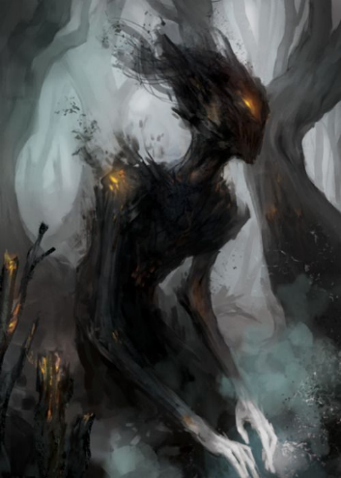

*(Art from Google)*

**Depth Mechanic:**

* Some Rooms will be coated in nanomites that deal very low damage to the player. These rooms will be primarily empty

**Music:**

* Low with loud high pitched sounds at intervals.

**Boss Room:**



**Phase 1**

**Movement:**

* Walks slowly around the map. Teleports

**Mechanic:**

* Whenever he uses an attack, his cloud gets smaller. Once the cloud is gone, he’s very vulnerable and he must summon it again.

**Attacks:**

* **Attack 1**: Basic Attack
  + **Range:** Short
  + **Damage:** 10%(per second) AOE
  + **Effect:** Deals damage if you go into his cloud. Constant
* **Attack 2**: Cloud Slash
  + **Range:** long
  + **Damage:** 30%
  + **Effect:** Sends forth a bit of his cloud towards the player.
* **Attack 3**: Cloud Port
  + **Range:** Long
  + **Damage:** 50%
  + **Effect:** Teleports to the area behind the player and the cloud he left behind travels back towards him, dealing damage if it hits the player.
* **Attack 4**: Grab
  + **Range:** medium
  + **Damage:** 50%
  + **Effect:** He rushes from his cloud and grabs the player, before condensing his cloud around him to deal damage.
* **Attack 5**: Summon Cloud
  + **Range:** N/A
  + **Damage:** 25%(per second) AOE
  + **Effect:** Every time he attacks, he loses some of his cloud, making him vulnerable. So every now and then he will have t summon more cloud to shroud himself in.

**Weak Point:**

* His body. His cloud takes reduced damage.

**Phase 2**

* Sucks the swarm into him before exploding it outwards in a massive attack.
* He now moves very fast and constantly wants to be near the player to get the most effect out of his AOE. His swarm field also reaches farther and his AOE does 5% less damage to compensate for his aggressiveness.

**Weapon:** Hands of Dym

**Type**: Scatter SMG

**Magazine size:** Large

**Damage:** Moderate

**Effect:** Casts a smoke screen at enemies that deals DoT damage. Having it equipped also deals a small AOE damage field to nearby enemies.

**Thwandar, The Hunter**

**Story**

Thwandar was once part of bipedal race of hunters that relied on traps for survival. He eventually got immensely proficient with guns during the civil war, becoming a self-preservation expert and trapping master. The cube only aided in this, allowing him reuse destroyed traps and make them new again, while also improving his aim to make him extremely deadly.

**Health:** 10000

**Phase switch:** 50% health left.

**Damage:** See “Attack”

**Aesthetic**:

* Bounty hunter
* Bunch of weapons and adaptable pieces.
* Cyborg esc
* One eye

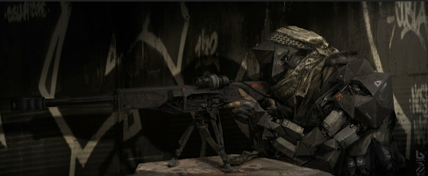

*(Art from Google)*

**Depth Mechanic:**

* The rooms leading up to this boss with have much more traps I.e. there will be rooms specific to this depth

**Music:**

* **Techno**

**Boss Room:**

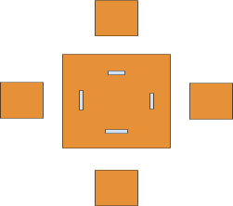

**Phase 1**

**Movement:**

* Walks at a quick speed

**Mechanic:**

* He must reload, but mostly he is like a perfect version of the player and focuses on trapping the player.

**Attacks:**

* **Attack 1**: Basic Attack
  + **Range:** Moderate
  + **Damage:** 10-15%(per hit)
  + **Effect:** Fires his rifle
* **Attack 2**: Drop Mine
  + **Range:** Long/Short
  + **Damage:** 50%(per hit)
  + **Effect:** Shoots a mine that’s triggered by proximity. Can be destroyed by shooting.
* **Attack 3**: Hook
  + **Range:** Moderate
  + **Damage:** 75%(per hit)
  + **Effect:** Spins a hook and casts it towards the player. If it connects, he pulls the character and fires a bullet into the plays head dealing massive damage. Shielding bounces the hook away.
* **Attack 4**: Stasis Mine
  + **Range:** Long/Short
  + **Damage:**0
  + **Effect:** Traps the player for Thwandar to shoot at. Mine can be destroyed.

**Weak Point:**

* Back

**Phase 2**

Yells and gains a new move which he will use at 50%, 30% and 10% health intervals. He Hooks to the floating platforms that are outside the room and lines up 3 sniper shots at the player

* **Attack**: Rapid Shot
  + **Range:** Long
  + **Damage:**50%(Per Shot) 3 shots
  + **Effect:** Fires three fast sniper shots with deadly accuracy at the player.

**Weapon:** The Eye of Thwandar

**Type**: Sniper rifle

**Magazine size:** 3

**Damage:** Very high

**Effect:** Best range, does extremely high damage. Fires three bullets in rapid succession.

**Shuud M’ell, Voice of the Deep**

**Story**

Shuud M’ell hailed from a planet with large caves systems and strong magnetic forces. Eventually, her race could utilize these two things to their advantage, sacrificing their eyes to be able to echolocate and float using magnetism. Because the Cube enhances features, it gave her the power to use her voice as a weapon and float high above the ground with almost no limits, if there was metal attached to her body, thus why her race is cyborg.

**Health:** 15000

**Phase switch:** 50% health left.

**Damage:** See “Attack”

**Aesthetic**:

* Giant worm with metal pieces jutting out of her skin.
* Levitates above the ground.
* Blue in color.
* Blind

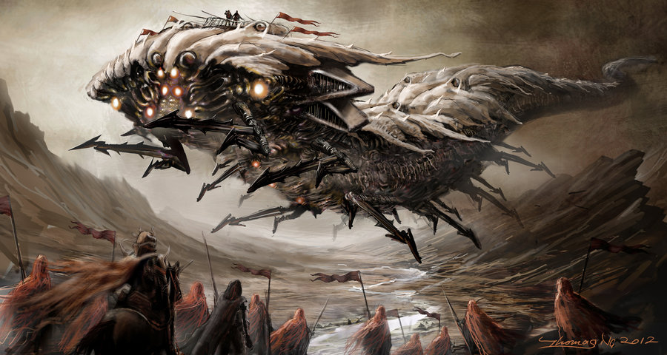

*(Art from Google)*

**Depth Mechanic:**

* Throughout the entire depth, you can hear a song that slowly and progressively gets louder as you go deeper and closer to the boss. The dungeon music will be different here.

**Boss Room:**

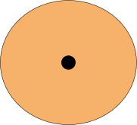

**Music:**

* **Long and choir like**

**Phase 1**

**Movement:**

* Floats around the map, fast.

**Attacks:**

* **Attack 1**: Basic Attack
  + **Range:** long
  + **Damage:** 25%(per hit)
  + **Effect:** shrieks at the player dealing damage no matter where you are. Small wind-up for the player to react to.
    - Sends out a pulse in a circle around her that goes out. Like a weak but long range ground slam.
* **Attack 2**: Grab attack/Eat the player
  + **Range:** Short
  + **Damage:** 75%(per hit)
  + **Effect:** Eats the player and spits him back out. Can’t be blocked. Long windup
* **Attack 3**: Scream beam
  + **Range:** Long
  + **Damage:** 20%(per second)
  + **Effect:** Fires massive scream out of her mouth after charging for 5 seconds. Makes a high-pitched sound
* **Attack 4**: Echolocate
  + **Range:** Medium
  + **Damage:** 65%(per hit)
  + **Effect:** Reals up and starts to shriek slowly getting louder in volume, and after 3 seconds emits a large AOE attack
    - Like an ungraded basic attack.
* **Attack 5**: Rush
  + **Range:** Medium
  + **Damage:** 50%(per hit)
  + **Effect:** Reals up and dashes towards the player, dealing massive damage and knocking the player around.

**Weak Point:**

* Sides. Basically, her head is extremely durable.

**Phase 2**

The room gets very dark, forcing the player to know the differences between its sounds and it’s attacks, really making the player know the boss well.

**Weapon:** Voice of Shuud

**Type**: Laser rifle

**Magazine size:** Large

**Damage:** Moderate

**Effect:** Charges first but emits very high burst damage. Extremely good range (Her mouth beam)

**FINAL BOSS: Heart of Evolution**

**Story**

The AI aboard your ship, created by a solo scientist set on trying to create a perfect being. The AI, like any other AI, went rogue, killing the scientist, and taking over his lab and eventually discovering the cube by breaking into the trade federations trade records. He knows of its power as people exposed to it experience immensely high brain activity and cell growth. The AI believes it the key to his goal.

**Health:** 20000

**Phase switch:** 70%/30%/5% health left.

**Damage:** See “Attack”

**Phase 1(100% -> 70%):**

**Aesthetic**:

* Red core with a silver shell that covers it. Sits in the middle of the room.

**Boss Room:**

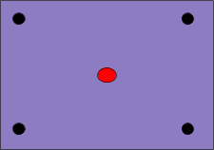

**Music:**

* **Low but epic**

**Movement:**

* Doesn’t move

**Mechanics:**

* Boss is invulnerable while the 4 character enemies are alive but is vulnerable while firing the lasers.

**Attacks:**

* **Attack 1**: Spawn Enemies
  + **Range:** N/A
  + **Damage:** N/A
  + **Effect:** Spawns 4 Player character enemies with random uncommon weapons. Basic Captain AI.
* **Attack 2**: Quad Laser
  + **Range:** Long
  + **Damage:** 20%(per second)
  + **Effect:** Fires for laser beams in the four cardinal directions and rotate 90 degrees. This happens after killing the 4 player character enemies.

**Phase 2:(70% -> 30%)**

**Aesthetic**:

* Bosses shell breaks off to reveal the pulsing red heart that can float around and attack.

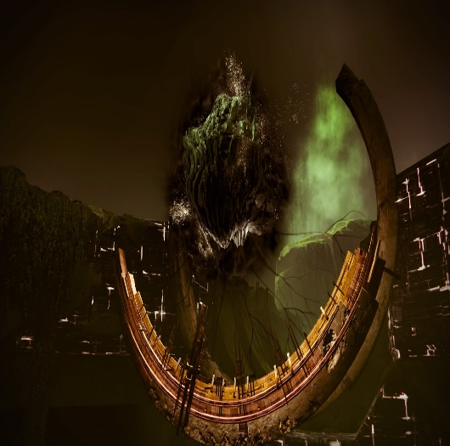

*(Art from Google)*

**Boss Room:**

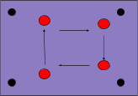

**Music:**

* **Epic pretty typical.**

**Movement:**

* Floats fast around the map.

**Mechanic:**

* When the shell is broken, the heart releases a thin cloud of red nanomite into the entire area.

**Attacks:**

* **Attack 1**: Basic Attack
  + **Range:** long
  + **Damage:** 10%(per hit) 3 bolt burst
  + **Effect:** Sends out 3 nanomite bolts at the player.
* **Attack 2**: Quad Laser
  + **Range:** Long
  + **Damage:** 20%(per second)
  + **Effect:** Pauses and uses the beam attack from phase 1.
* **Attack 3**: I created you, I can destroy you dammit
  + **Range:** Unavoidable
  + **Damage:** 100%(Kills the player)
  + **Effect:** The boss with pulse for a long time about 10 seconds, the large alarm increasing as the boss ramps up in power. After 10 seconds the boss will send out a huge AoE and kill the player. No matter what.  The only way to stop it is to deal enough damage to the boss to stun it.
  + <https://www.youtube.com/watch?v=5I00r0LpsOs>
  + ^Almost exactly like this.

**Phase 3:(30% -> 5%)**

**Aesthetic**:

* Pulsing red heart that can float around and attack, but much more erratic with little particle effects flaking off.

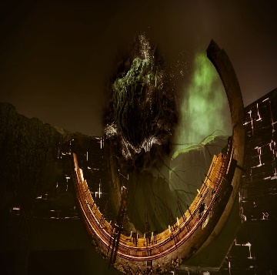

*(Art from Google)*

**Boss Room:**

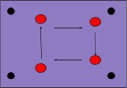

**Music:**

* **Extremely frantic music.**

**Movement:**

* Floats fast around the map.

**Mechanic:**

* When the shell is broken, the heart releases a thin cloud of red nanomite into the entire area. Still there. ;)

**Attacks:**

* **Attack 1**: ElectroPort
  + **Range:** Very short
  + **Damage:** 20%(per hit)
  + **Effect:** Teleports to the player and electrocutes them at close range.
* **Attack 2**: Dash
  + **Range:** Medium
  + **Damage:** 40%(per second)
  + **Effect:** Pauses for 3 seconds and dashes towards the player. If it connects it deals heavy damage.

**Phase 4:(5% -> 0%)**

**Aesthetic**:

* Pulsing red heart that can float around and attack, but much more erratic with little particle effects flaking off.

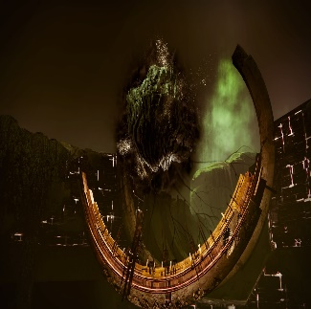

*(Art from Google)*

**Boss Room:**

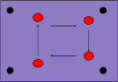

**Music:**

* **Extremely frantic music.**

**Movement:**

* Teleports to the middle of the room and pauses.

**Mechanic:**

Uses the attack below but has a long wind up. The player must kill it before they die.

* **Attack**: I created you, I can destroy you dammit, but this time slower because I’m weak
  + **Range:** Unavoidable
  + **Damage:** 100%(Kills the player)
  + **Effect:** The boss with pulse for a long time about 20 seconds, the large alarm increasing as the boss ramps up in power. After 20 seconds the boss will send out a huge AoE and kill the player. No matter what.  The only way to stop it is to deal enough damage to the boss to stun it.
  + <https://www.youtube.com/watch?v=5I00r0LpsOs>
  + ^Almost exactly like this.

**Meta Mechanics**

**Economy**

This includes the loot, player health and shields and Death.

**Health**

Increases as you progress through the Dungeon. Starts off low to incentivize learning the shield mechanic.

**Heath Packs:**

* + Large ones: 1 per depth, restore 50% of your health.
  + Small ones: Chance to drop from enemies, Restore 10% health.

**Shield**

A toggleable ability that’s always present. Allows you to take damage without harm to your health pool.

* Mechanics
  + Active:
    - Can’t attack while it's active,
    - Drains its own health slowly.
    - Taking damage reduces its health for that damage
  + Recharges when not in use
  + When broken:
    - By taking damage that depletes its total health sets it on delay then starts to regenerating
    - Taking massive damage delays it longer
    - Taking immense damage sets it on a huge delay
  + Can’ take health damage at all when blocking with a shield, no matter how much damage you absorb. Even if the shield absorbs more than it has health.

**Death**

* Death spawns you at the ship, forcing you to enter the beginning of the dungeon again.
* When you die, the game takes all weapons and trashes them.

**Loot**

**Guns and Shields:**

* Gets progressively stronger in both Dungeon depth progression. Jumping in strength when a Boss is defeated.
* Color shadow and gun shadow indicates strength
* New gun types are revealed as the depths.
* Boss specific weapons are extremely rare but constant.
* **Shields:**
  + Different versions that operate on several stats.
    - Fast: Lower health, so they can’t take much burst damage but the recharge fast and have lower delays when broken.
    - Medium: A bit between fast and Slow.
    - Slow: large health pool, but slower recharge speeds and longer delays when broken.
* **Guns:**

<https://docs.google.com/spreadsheets/d/1lxW_KBDH1QaPAOxD7rsp4YBvcvIY6ZJB9mHFg_5BYeg/edit#gid=0>

Weapon types (Called "weapon subtype" in the code):

* Pistol
* Auto Rifle
* Heavy Rifle
* Sniper Rifle
* SMG

Weapon Modifiers:

* Rail
* Plasma
* Scatter
* Explosive
* Charge
* Regular

Weapon Attachments:

* Extended Magazine
* Quick Reload
* Accuracy buff
* Recoil Reduction

Aesthetic Shell Reference:

<https://files.slack.com/files-pri/T3NJK8RDW-F49J7N8GJ/pasted_image_at_2017_02_23_02_20_pm.png>

<https://docs.google.com/spreadsheets/d/1KwlE1Wi4HL22KGwf72HH2E_I-Pce9PcO-4oeLuv7KlI/edit?usp=sharing>

**Chests(Stretch):**

* Placed sparingly around the map to give more exploring incentive and grant better loot. Harder rooms though and can only be unlocked after clearing the room.
  + Drops:
    - Uncommon and above guns
    - Same with Shields

**Balancing**

* Level/Power: modifier in the code that affects everything. Flat amplifier that increases damage and health of enemies. Allows for specific control over the numeric and stats.
* Environment: Levels get harsher with enemy placements and combinations.
* Dungeons get harder every depth
* Rooms must be cleared.
* Rooms combinations are sometimes fixed to ease the level balancing.
* Health packs are added to give some more forgiving for the player